EXP 2
Analysis of SWR (Standing Wave Ratio)Transmission Lines by varying a)load impedance b) characteristic impedance
Test Case 1:
AIM: To analyze the SWR of a transmission line for a fixed characteristic impedance (Zo) of 50 ohms, as the load impedance (ZL) is varied across the following values: 25 ohms, 50 ohms, 75 ohms, and 100 ohms. To verify how the SWR changes with each value of ZL and when ZL =Zo.

PROGRAM:
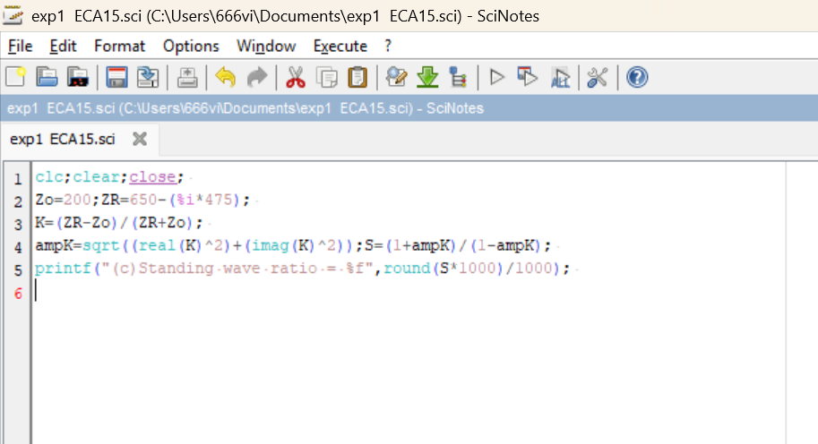

OUTPUT:
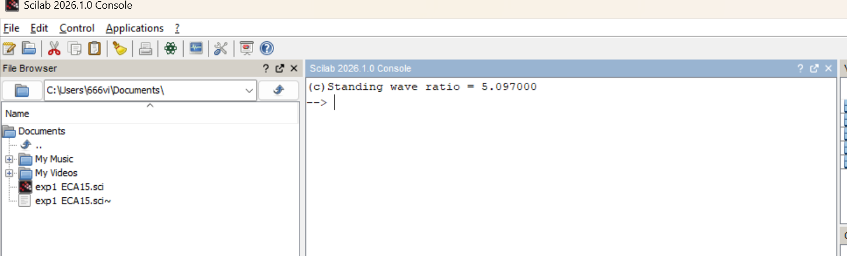

Test Case 2:
AIM: To analyze the SWR of a transmission line for a fixed characteristic impedance (Zo) of 50 ohms, as the load impedance (ZL) is varied across the following values: 25 ohms, 50 ohms, 75 ohms, and 100 ohms. To verify how the SWR changes with each value of ZL and when ZL =Zo.

PROGRAM:

OUTPUT:

